Student database

Create a database “Student” with the following attributesRollno, Age, ContactNo, EmailId?
use Student
db.createCollection("student")

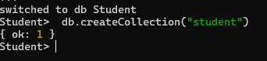

Insert appropriate values?
db.student.insertMany([{ Rollno: 10, Name: "ABC", Age: 20, ContactNo: "9876543210", EmailId: "abc@gmail.com" },{ Rollno: 11, Name: "ABC", Age: 21, ContactNo: "9876543211", EmailId: "abc11@gmail.com" }, { Rollno: 12, Name: "XYZ", Age: 22, ContactNo: "9876543212", EmailId: "xyz@gmail.com" }])

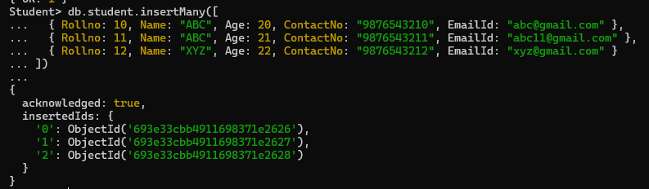

Write query to update Email-Id of a student with rollno 10?
db.student.updateOne( { Rollno: 10 }, { $set: { EmailId: "newemail10@gmail.com" } } )

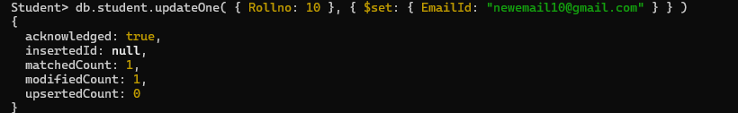

Replace the student name from “ABC” to “FEM” of rollno 11?
db.student.updateOne( { Rollno: 11, Name: "ABC" }, { $set: { Name: "FEM" } }

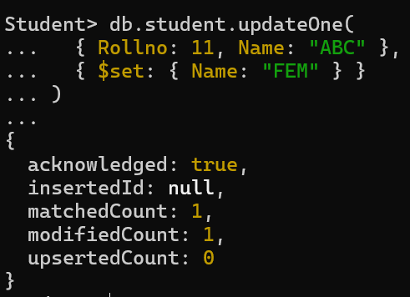

Drop the table.
db.student.drop()
